### Report On Comparative Analysis of Android and macOS



Session-Spring-24

**Submitted by:**

**Name:** Abdur Rahman

**ID:**221457

**Section:** BSCS-V-C

**Submitted to:** Ma’am Warda Aslam

**Date:**29-December -2024

### Comparative Analysis of Android and macOS

#### Summary of Research Papers

The research paper compares major operating systems, emphasizing architectural aspects as well as their features and applications. Of the systems analyzed, Android and macOS were underscored for use in mobile and desktop environments, respectively. Among the major differences, distinctions were target audiences, security mechanisms in both systems, and adaptability of the hardware it works with. As well as being open-source, the "Android" platform is very flexible and customizable. But on the other hand, macOS focuses more on security and stability within the Apple ecosystem.[1]

#### Comparison of OS Concepts [1]

**1. Process Management**

* **Android:**
  + Android uses the Linux kernel, supporting preemptive multitasking. Processes are created and managed via the Zygote process, which minimizes overhead by forking pre-initialized instances.
  + Inter-process communication (IPC) is facilitated through Binder, a lightweight and efficient mechanism.
  + Multitasking is app-centric, allowing users to switch between apps while the system prioritizes foreground processes. [1]
* **macOS:**
  + macOS employs a hybrid XNU kernel, combining elements of Mach and BSD.
  + Processes are managed using sophisticated scheduling algorithms, such as fair-share and real-time scheduling.
  + IPC is supported through mechanisms like Mach messaging and shared memory. [1]

**2. Memory Management**

* **Android:**
  + Utilizes paging and kernel-level memory allocation.
  + Implements a garbage collector for automated memory deallocation, critical for app-heavy environments.
  + Relies on a compressed RAM feature to manage memory efficiently in low-resource situations. [1]
* **macOS:**
  + Supports advanced memory management with virtual memory, ensuring applications have consistent access to memory.
  + Features memory compression and caching to improve performance.
  + Offers robust memory protection to isolate processes and safeguard system integrity. [1]

**3. File System**

* **Android:**
  + Primarily uses the ext4 file system, optimized for flash memory.
  + Supports other file systems like FAT32 and exFAT for external storage.
  + Manages files through the MediaStore API, ensuring structured access. [1]
* **macOS:**
  + Utilizes the Apple File System (APFS), known for its high performance and encryption capabilities.
  + Supports hierarchical file management with metadata indexing for efficient searches.
  + Features snapshots for quick backups and recovery. [1]

**4. Security**

* **Android:**
  + Employs sandboxing for app isolation, preventing unauthorized access to system resources.
  + Implements device encryption and biometric authentication.
  + Vulnerable to malware due to its open-source nature and app diversity. [1]
* **macOS:**
  + Enforces stringent app vetting through the App Store.
  + Integrates hardware-based security, such as the T2 Security Chip.
  + Includes Gatekeeper and FileVault for malware prevention and data encryption. [1]

**5. Scheduling**

* **Android:**
  + Uses a priority-based scheduler within the Linux kernel.
  + Supports real-time processing through task prioritization. [1]
* **macOS:**
  + Employs multi-queue CPU scheduling for task distribution.
  + Optimized for multi-user and multi-process scenarios. [1]

#### Creative Analogy

Comparing Android and macOS is like comparing a bustling city to an exclusive island resort:

* Android represents the city, bustling with diversity and customization. It accommodates everyone’s needs but requires careful navigation to avoid pitfalls.
* macOS is the island resort, meticulously designed for a select audience, offering a secure and seamless experience but at a premium cost. [1]

#### Insights and Observations

* Android’s open-source model fosters innovation but exposes it to higher security risks.
* macOS offers unparalleled integration and reliability, excelling in environments where security and stability are paramount.
* Both systems cater to different user bases: Android thrives in customization and affordability, while macOS targets high-end users valuing ecosystem cohesion. [1]

|  |  |  |  |  |  |  |  |  |  |
| --- | --- | --- | --- | --- | --- | --- | --- | --- | --- |
| **CRITERIA**  **OS NAME** | GUI | Security | Hardware Compatibility | Memory Management | Text Mode Interface | Architecture | File System | Portability | Process Management |
| WINDOWS 10 [2] | 1 | 4 | 1 | 2 | 2 | 3 | 2 | 1 | 1 |
| ANDRIOD 10.0 [2] | 3 | 3 | 2 | 3 | - | 4 | - | - | 4 |
| MAC OS X [2] | 2 | 2 | 4 | 1 | 3 | 2 | 3 | 3 | 3 |
| LINUX (Ubuntu 17.4) [2] | 4 | 1 | 3 | 4 | 1 | 1 | 1 | 2 | 2 |

### Key Points of the Table [2]:

1. **Criteria**: Each column (e.g., GUI, Security, Hardware Compatibility) represents a quality attribute or feature of the operating systems being evaluated.
2. **Operating Systems (OS Name)**: Rows correspond to specific operating systems being analyzed.
3. **Rankings (1 to 4)**:
   * A ranking of **1** indicates the lowest preference for that criterion.
   * A ranking of **4** indicates the highest preference for that criterion.
   * The rankings are used to **compare the OSes' performance or suitability** for that specific feature.
4. **Missing Data (-)**: Some features (e.g., Text Mode Interface, Architecture) are not applicable or evaluated for certain operating systems (e.g., Android).

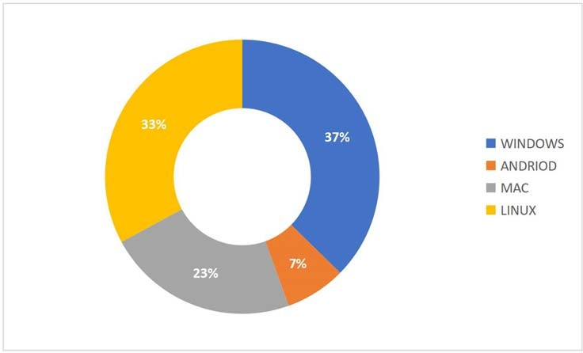

Figure 1: Pie Chart of Operating System User Preference [2]

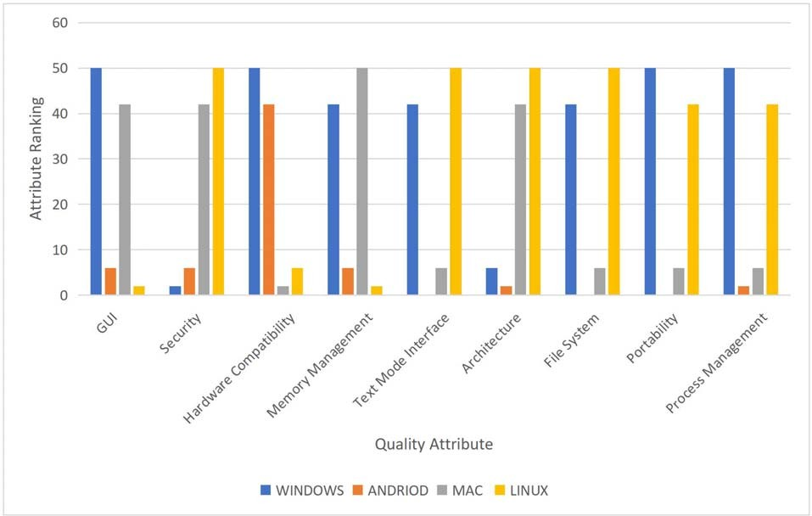

Figure 2: Bar Chart of Evaluation Metrics [2]

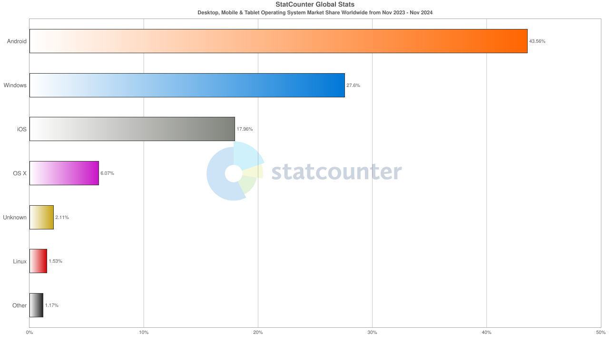

Figure 3: Desktop, Mobile & Tablet Operating System Market Share Worldwide [3]

### Conclusion:

# An analysis comparing Android to macOS will show that with these different facts molding features into their own merits, both systems are very much proved to do good as far as serving ends in different user bases and functional needs:

# Android: Android proves to be that is fully open source-foray to the innovations and the customizations it owns. The multitasking ability within this software system leads to a mobile environment, designing it to a very big extent suited for users who value flexibility and economy. In contrast, vulnerable it is to security risks, mainly since being open-source, as well as the fragmentation it brings about within the devices.

# macOS: The macOS is all about security, stability, and very high performance when compared with any other operating system in the process in which it operates as part of the Apple ecosystem in terms of workflow. Memory managing techniques further state that the progressive nature and, of course, a highly reliable and efficient file system, APFS, provide a great deal of reliability and efficiency, especially in projection mediums or professional setups. However, the unique selling proposition (USP) and higher price tag don't make it very accessible.

# Both exhibit outstanding process-movement behavior and memory management capabilities, with excellent scheduling and secure environments, all tailored according to their targeted audiences. Android thrives on both accessibility and huge user diversity while macOS leads by providing an integrated and high-end user experience.

# Lastly, the preference between Android and macOS will greatly depend on how a user can prioritize between customization and affordability for an integration into a system that affords maximum reliability.

# References

1. [Abdullahi Idris, Dr. Aminu Abdullahi Aliyu and Umar Saminu Muhammad, " Comparative Analysis of Modern Operating Systems," *Nigerian Journal of Computing, Engineering and Technology (NIJOCET) Vol. 1 No. 2 December 2022 ISSN: 2955 – 0580*.](https://nijocet.fud.edu.ng/wp-content/uploads/2023/09/NIJOCET-VOL2-ID005.pdf)
2. [saac Odun-Ayo, Kennedy Okokpujie, Kingsley Oputa, Henry Ogbu, Franklin Emmanuel, Ayobami Shofadekan and Gideon Okuazun, "Comparative Study of Operating System Quality Attributes," in *Isaac Odun-Ayo et al 2021 IOP Conf. Ser.: Mater. Sci. Eng. 1107 012061*.](https://iopscience.iop.org/article/10.1088/1757-899X/1107/1/012061/pdf)
3. [Desktop, Mobile & Tablet Operating System Market Share Worldwide, https://gs.statcounter.com/os-market-share/desktop-mobile-tablet/worldwide/#monthly-202311-202411-bar.](https://gs.statcounter.com/os-market-share/desktop-mobile-tablet/worldwide/#monthly-202311-202411-bar)